Data Engineering -Course

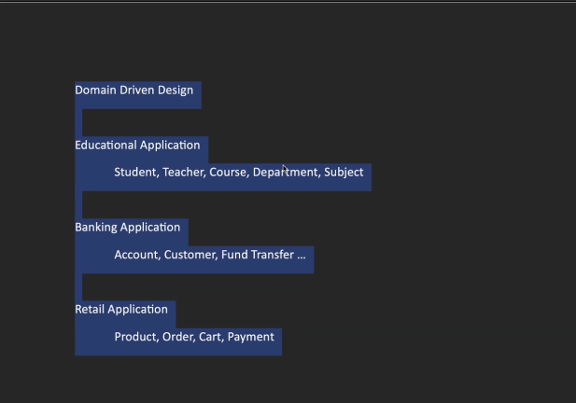

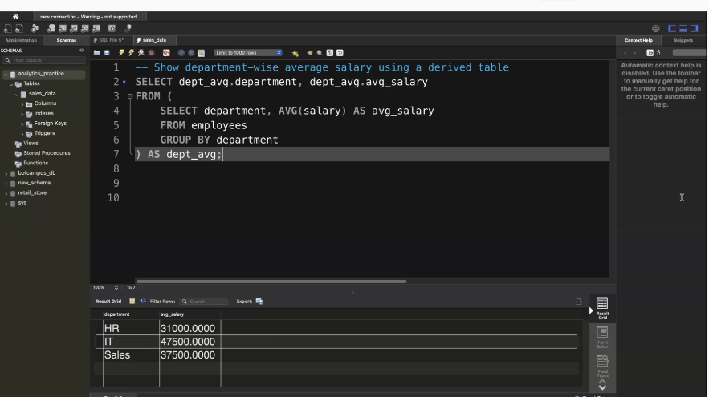

CREATE DATABASE simple_sql;  
USE simple_sql;

CREATE TABLE employees (  
    emp_id INT PRIMARY KEY,  
    emp_name VARCHAR(100),  
    department VARCHAR(50),  
    salary INT,  
    age INT  
);

INSERT INTO employees VALUES  
(1, 'Amit', 'HR', 30000, 25),  
(2, 'Neha', 'IT', 45000, 28),  
(3, 'Rahul', 'IT', 50000, 30),  
(4, 'Divya', 'Sales', 40000, 26),  
(5, 'Kiran', 'Sales', 35000, 24),  
(6, 'Meena', 'HR', 32000, 29);

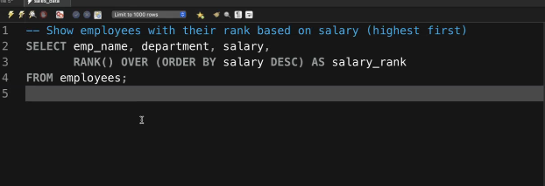

use analytics_practice;

CREATE TABLE customers (  
    customer_id INT PRIMARY KEY,  
    customer_name VARCHAR(100),  
    city VARCHAR(50)  
);

INSERT INTO customers VALUES  
(1, 'Amit Sharma', 'Delhi'),  
(2, 'Neha Reddy', 'Hyderabad'),  
(3, 'Rahul Iyer', 'Mumbai'),  
(4, 'Divya Mehta', 'Chennai');

CREATE TABLE orders (  
    order_id INT PRIMARY KEY,  
    customer_id INT,  
    product_name VARCHAR(100),  
    order_amount INT,  
    FOREIGN KEY (customer_id) REFERENCES customers(customer_id)  
);

INSERT INTO orders VALUES  
(101, 1, 'Laptop', 55000),  
(102, 2, 'Mouse', 500),  
(103, 1, 'Keyboard', 1500),  
(104, 3, 'Monitor', 7000),  
(105, 2, 'Printer', 8500);

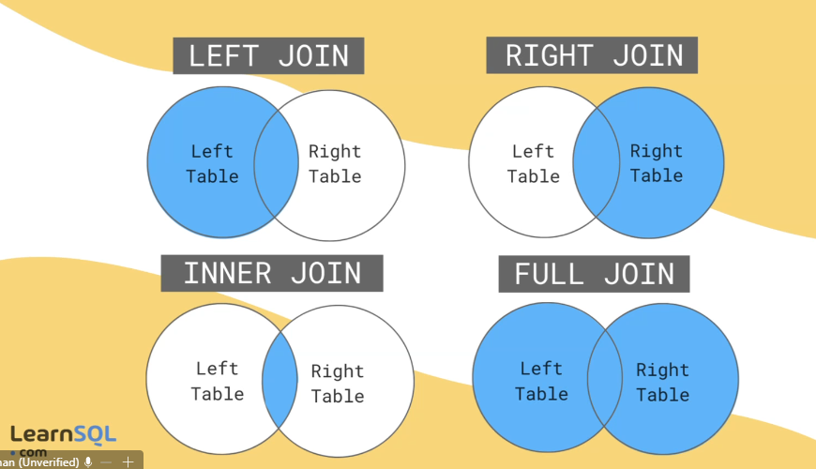

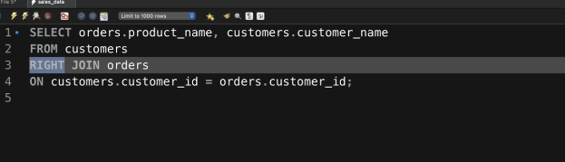

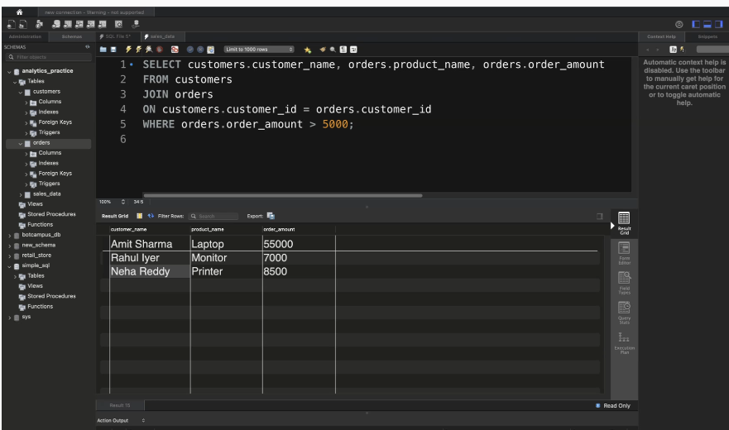

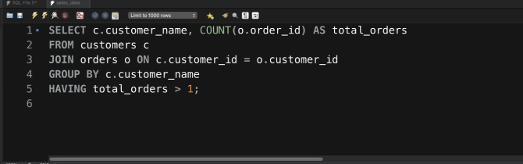

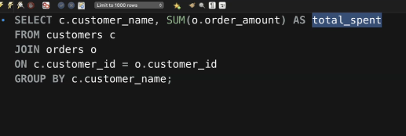

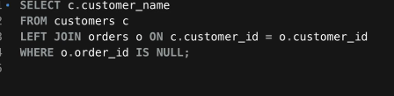

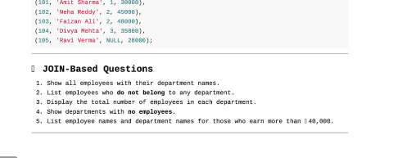

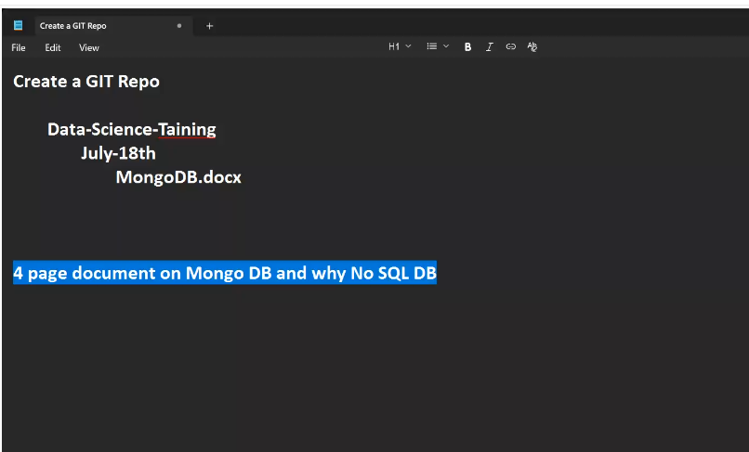

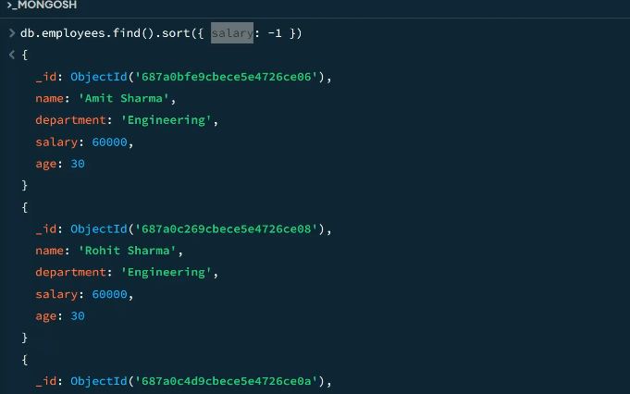

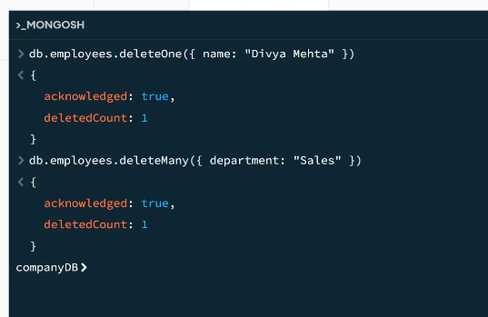

db.Employee.deleteMany({$and:[{department:"Sales"},{age:{$gte:45}}]})